**Everything you need to know about the theorems:**

Read the limit paper before this one. This theorem is used to simplify limits that seem at first glance to not have an answer. It is used rarely in mathematics, but it’s introduced in this course to give a better understand of how to use the delta-epsilon paradigm for proving. First, the formal definition:

$$If:$$

$$f,g,h:\left(a,b\right)→R, c∈\left(a,b\right),$$

$$f\left(x\right)≤g\left(x\right)≤h\left(x\right)∧ \lim_{x→c}{f\left(x\right)}=L= \lim_{x→c}{h\left(x\right)}$$

$$then:$$

$$\lim_{x→c}{g\left(x\right)}=L$$

After looking at the limit paper, it should be quite clear what this signifies. Since f(x) and g(x) must be less and greater then h(x), respectfully, then when f(x) and h(x) are equal to L, then it’s clear that g(x) will also equal L.

The proof of this relies on the definition: $f\left(x\right)≤g\left(x\right)≤h\left(x\right)$.

Proof:

$$let ϵ>0 be given and δ_{f}∧δ_{h}>0, s.t.$$

$$0< \left|x-c\right|<δ_{f}⇒ \left|f\left(x\right)-L\right|<ϵ$$

$$and \\ 0< \left|x-c\right|<δ_{h}⇒ \left|h\left(x\right)-L\right|<ϵ$$

In this step, we simply established the standard epsilon-delta definitions of the limit. Note that we’re using two different deltas. This is to show that you don’t need to use the same delta. The smallest delta will be chosen anyways later on, so this is just a mathematical pedantry.

$$set δ=\min\left\{δ_{f}, δ_{h}\right\}$$

$$if:$$

$$0< \left|x-c\right|<δ for both$$

$$\left|f\left(x\right)-L\right|<ϵ and \left|h\left(x\right)-L\right|<ϵ$$

$$then:$$

$$L-ϵ<f\left(x\right)<L+ϵ L-ϵ<h\left(x\right)<L+ϵ$$

Some mathematical manipulations occurred that just expand the more formal definition into something more understandable. Now, following the crucial triple inequality pointed out earlier:

$$L-ϵ<f\left(x\right)≤g\left(x\right)≤h\left(x\right)<L+ϵ$$

You’re allowed to plug this in because every value of x is converging towards c. This means you could take out the inequalities and the two functions, and then just leave g(x) in the epsilon band.

$$L-ϵ<g\left(x\right)<L+ϵ$$

$$-ϵ<g\left(x\right)-L<ϵ$$

$$\left|g\left(x\right)-L\right|<ϵ$$

$$Q.E.D.$$

Now let’s use this in practice:

Show that

$$\lim_{x→ 0}{x^{2}{\sin\left(\frac{1}{x}\right)=0}}$$

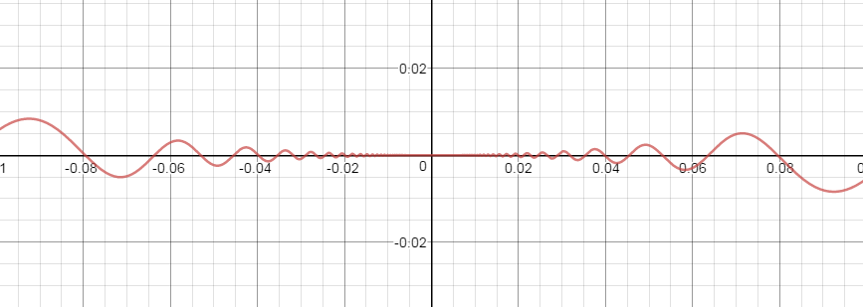The trick is to put this function between two other functions that both equal zero at x -> 0 and are consistently smaller and larger than this function. If it isn’t clear what function can squeeze your starting one, start with an equality you know

$$note : -1<\sin\left(\frac{1}{x}\right)<1$$

This comes from the function being bounded. With this, we want to get our original function bounded between two functions we know the value of. This is the hardest part of the whole exercise, and could require a lot of practice. This example is coincidentally easy, it being the typical example of the squeeze theorem.

$$-1<\sin\left(\frac{1}{x}\right)<1$$

$$-x^{2}<x^{2}sin\left(\frac{1}{x}\right)<x^{2}$$

Looking at the graph of this inequality, it is clear that this inequality holds

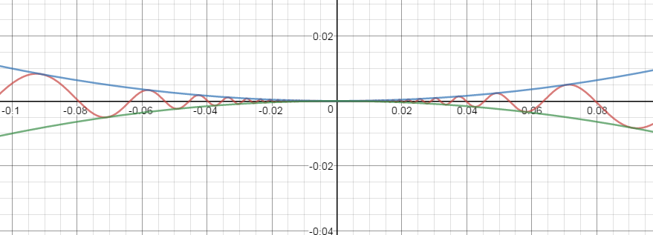

$$Now we can do \lim_{x→0}{-x^{2}}=0= \lim_{x→0}{x^{2}}$$

$$So, by the squeeze theorem$$

$$\lim_{x→ 0}{x^{2}{\sin\left(\frac{1}{x}\right)=0}}$$

$$Q.E.D.$$

These last four lines are crucial for getting full marks. Write the limit of the two squeezing functions, state that you’re using the squeeze theorem, give the answer, and write Q.E.D. These steps are crucial for full marks.

**Harder use of the squeeze theorem**

Let’s prove this:

$$\lim_{x→0}{x\sin\left(\frac{1}{x}\right)=0}$$

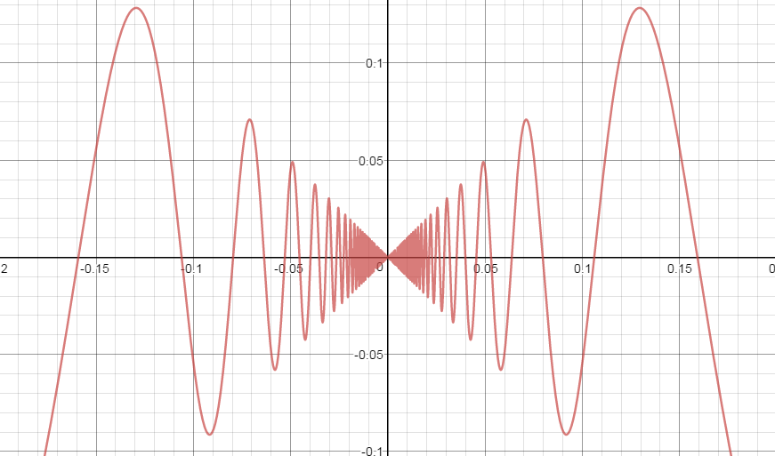

At first glance, it looks like the same technic that was used before can be used again. However,

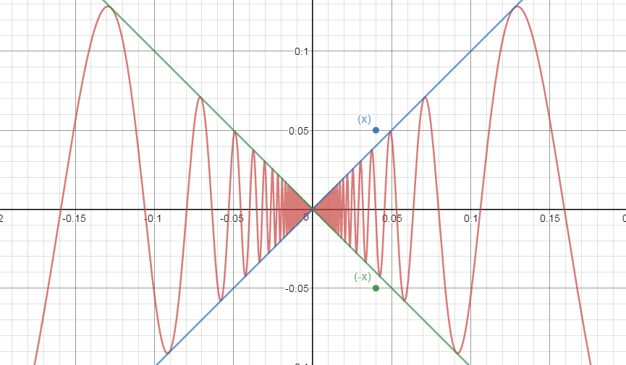

The function x and –x both go over and under the graph. I.e.

$$∀x∈R , f\left(x\right)≰g\left(x\right)≰h(x)$$

To solve this, there are two possible approaches:

1. Realise that the proof of the squeeze theorem also holds for 1-sided limits

* This you signify that we could take the left and right limit and show how both of them will equal 0

1. Proof that if $f:\left(a,b\right)→R∧c∈\left(a,b\right)⇒ \lim_{x→c}{f\left(x\right)=0}⇔\lim_{x→c}\left|f\left(x\right)\right|=0 when the limit= 0$

**Squeeze theorem applications you need to know the result**

$$f\left(x\right)=\frac{\sin\left(x\right)}{x}=1$$

This graph looks like this

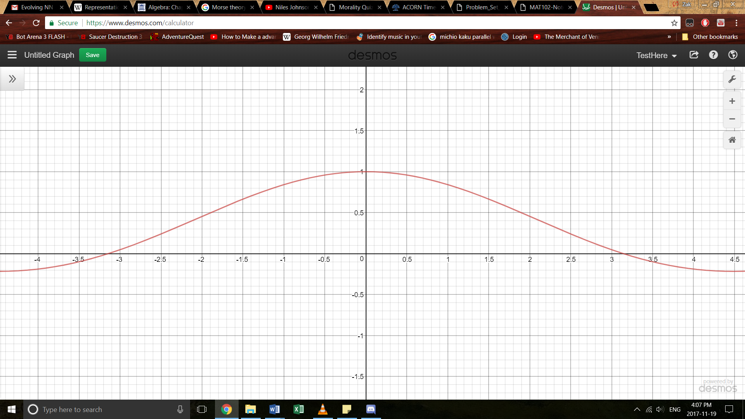

Which has a definite solution when $\lim_{x→0}{f(x)}$. This could be used using fancy squeeze theorem stuff. You don’t need to know how, but here’s a quick visual if you’re curious, here’s a visual and the link to the demos page I created:

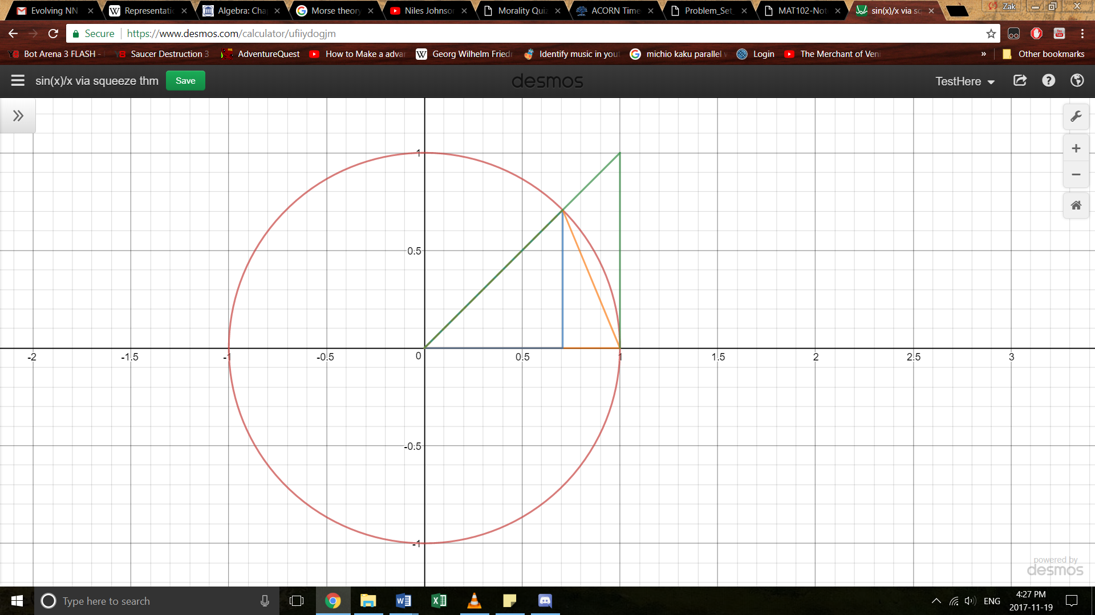

<https://www.desmos.com/calculator/i5092xkqpv>

Working on this limit, you could prove that

$$\lim_{x→0}{\frac{\cos\left(x\right)}{x}=0}$$